EX. NO: | SIMPLE LOGIN FORM USING REACT JS
DATE: | SIMPLE LOGIN FORM USING REACT JS

AIM:
To create a simple login form using React JS that accepts username and password from the user and displays a login success message.

ALGORITHM:

STEP 1: Start the program.
STEP 2: Create a React component named LoginForm.
STEP 3: Initialize state variables for username, password, and message using useState().
STEP 4: Create input fields for username and password.
STEP 5: Read user input using onChange event.
STEP 6: Create a Login button.
STEP 7: When the button is clicked, validate the entered username and password.
STEP 8: If both fields are filled, display “Login Successful”.
STEP 9: Otherwise, display “Please enter username and password”.
STEP 10: Display the result message on the screen.
STEP 11: Stop the program.

PROGRAM CODE:

App.jsx
import LoginForm from "./LoginForm";

function App() {
return <LoginForm />;
}

export default App;

LoginForm.jsx
import { useState } from "react";

export default function LoginForm() {
const [username, setUsername] = useState("");
const [password, setPassword] = useState("");
const [msg, setMsg] = useState("");

const handleSubmit = (e) => {
e.preventDefault();

if (username === "admin" && password === "1234") {
setMsg("Login Successful ✅");
} else {
setMsg("Invalid Credentials ❌");
}
};

return (
<div style={styles.container}>
<div style={styles.box}>
<h2 style={styles.title}>Login</h2>

<form onSubmit={handleSubmit}>
<input
type="text"
placeholder="Username"
style={styles.input}
onChange={(e) => setUsername(e.target.value)}
/>

<input
type="password"
placeholder="Password"
style={styles.input}
onChange={(e) => setPassword(e.target.value)}
/>

<button type="submit" style={styles.button}>
Login
</button>
</form>

<p>{msg}</p>
</div>
</div>
);
}

const styles = {
container: {
height: "100vh",
display: "flex",
justifyContent: "center",
alignItems: "center",
background: "linear-gradient(135deg, #667eea, #764ba2)"
},
box: {
background: "#fff",
padding: "30px",
borderRadius: "12px",
width: "300px",
textAlign: "center",
boxShadow: "0 8px 20px rgba(0,0,0,0.2)"
},
title: {
marginBottom: "20px"
},
input: {
width: "100%",
padding: "10px",
margin: "10px 0",
borderRadius: "6px",
border: "1px solid #ccc"
},
button: {
width: "100%",
padding: "10px",
background: "#667eea",
color: "#fff",
border: "none",
borderRadius: "6px",
cursor: "pointer",
marginTop: "10px"
}
};

main.jsx
import { StrictMode } from 'react'
import { createRoot } from 'react-dom/client'
import './index.css'
import App from './App.jsx'

createRoot(document.getElementById('root')).render(
<StrictMode>
<App />
</StrictMode>,
)

OUTPUT:

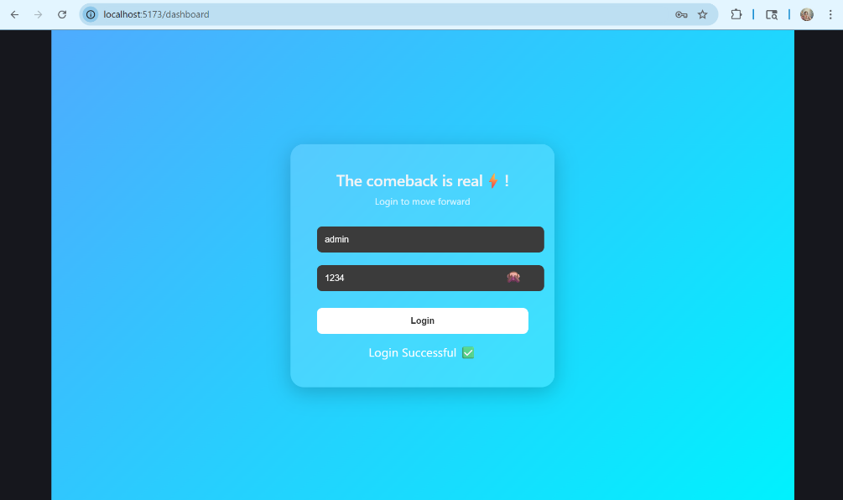

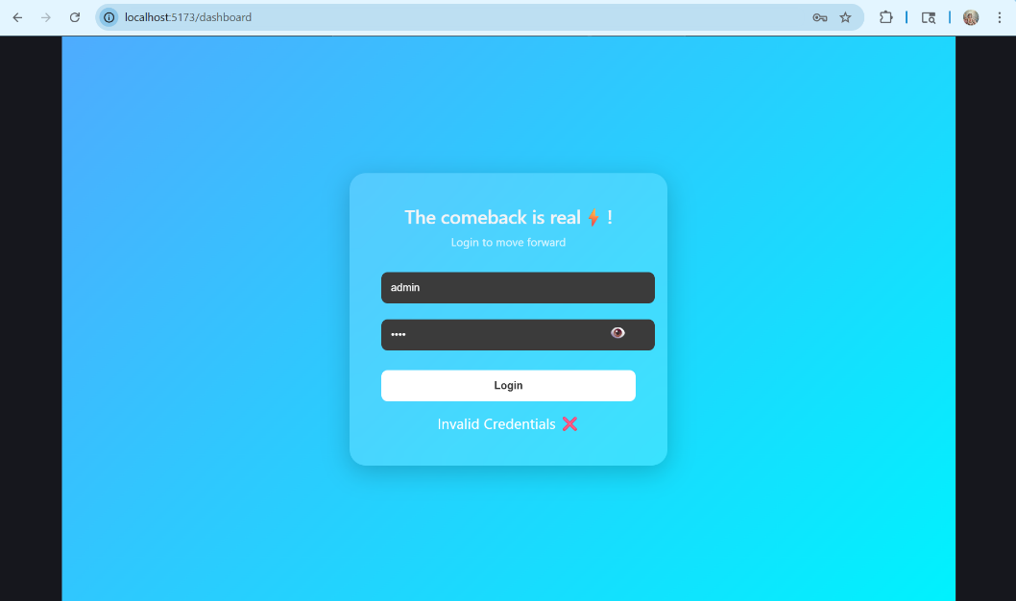

RESULT:
Thus, the simple login form was successfully created using React JS and the user
login was validated successfully.

